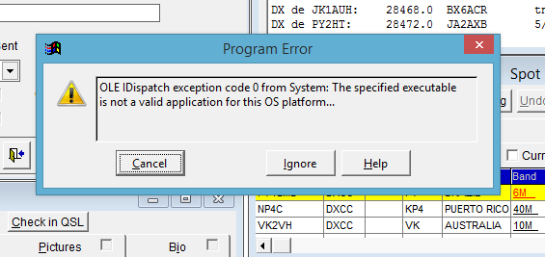

I selected Ignore, then I got:

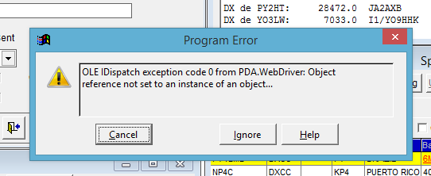

I selected Ignore again, and it went away without doing anything else, it just went back to the Logging screen.

