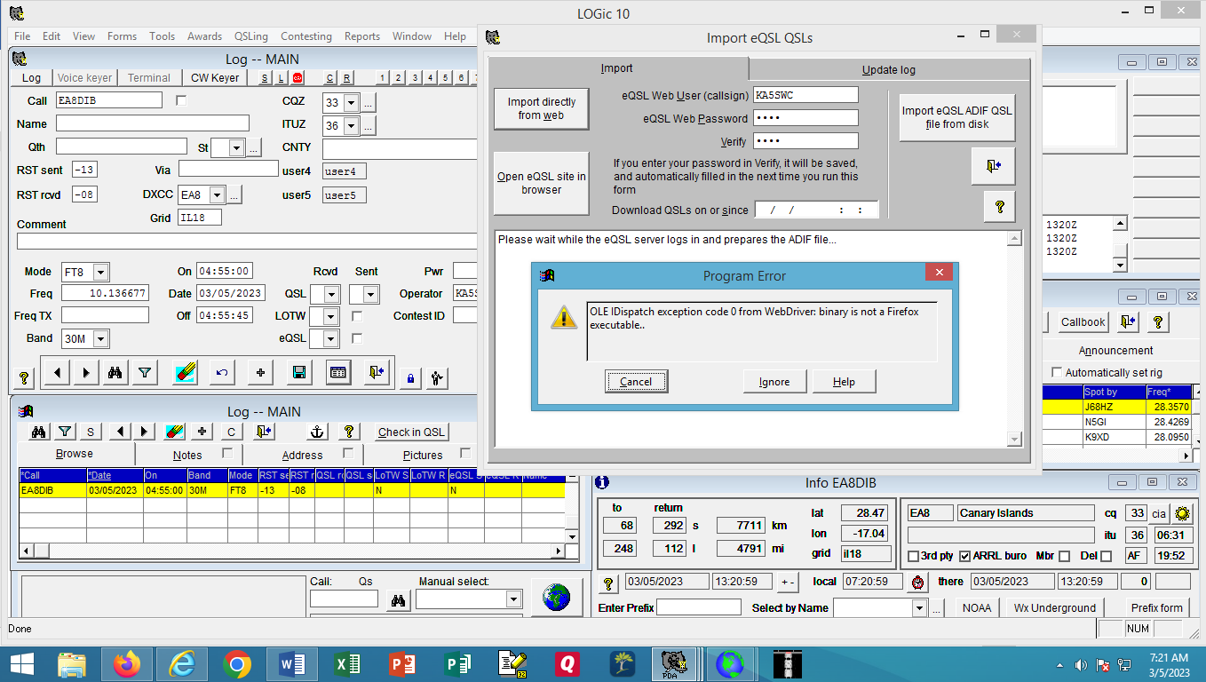
Here, I initiated an import from eQSL from the Import Directly from Web tab: when I click CANCEL, the process shuts down LOGic.

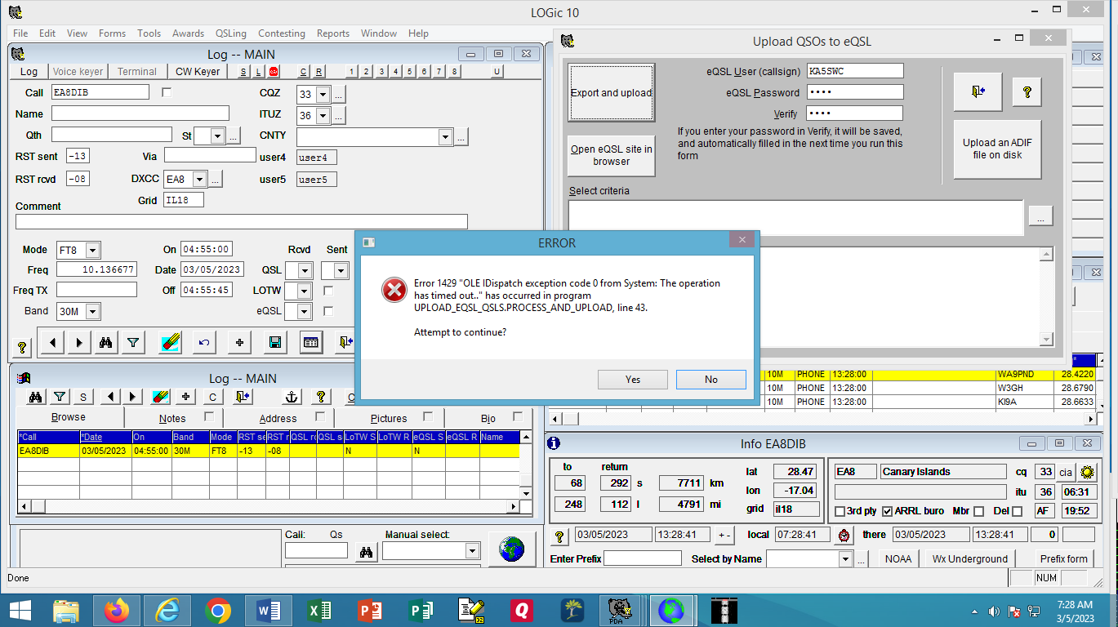

This is when I initiated the process to upload, I got this likely because I live in a fairly rural South Texas town and my internet is the PITS!

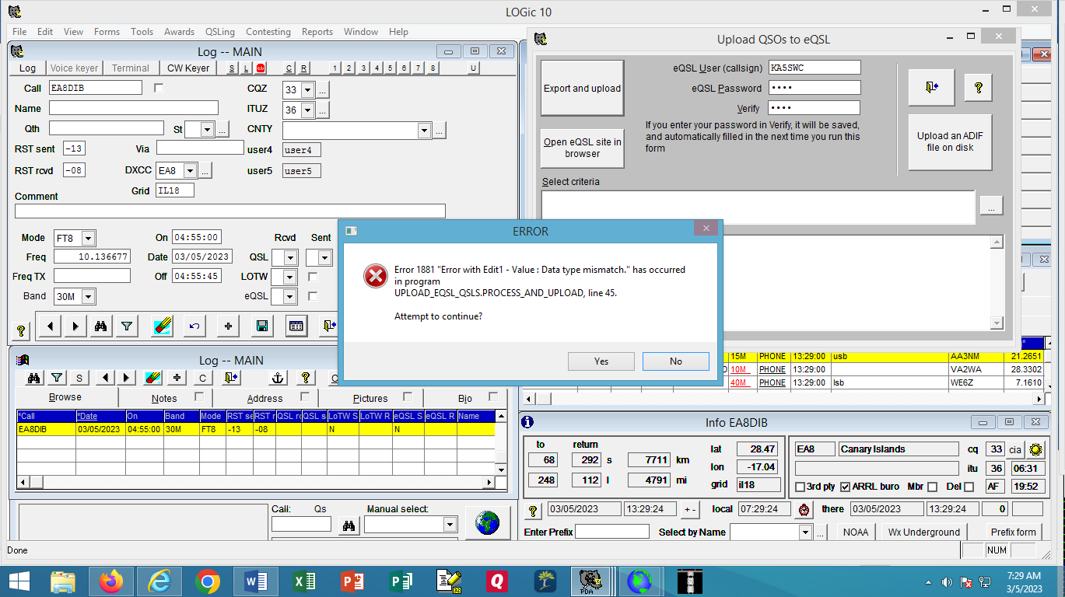
Then I got this, and when I selected NO, it too closed down LOGic.

