On the upload:
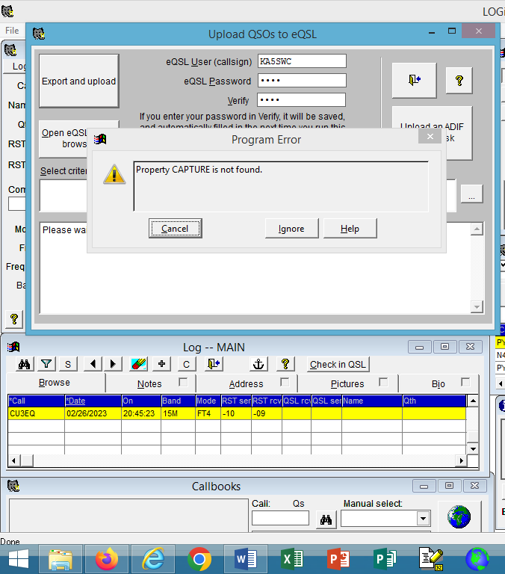 this says: Property CAPTURE is not found
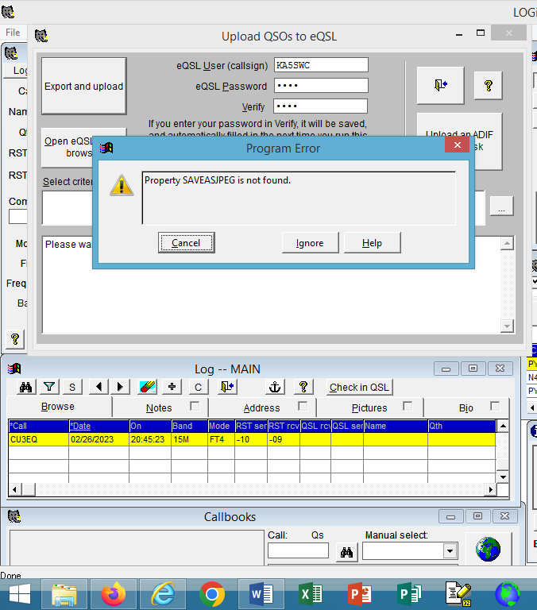 this says: Property SAVEASJPEG is not found

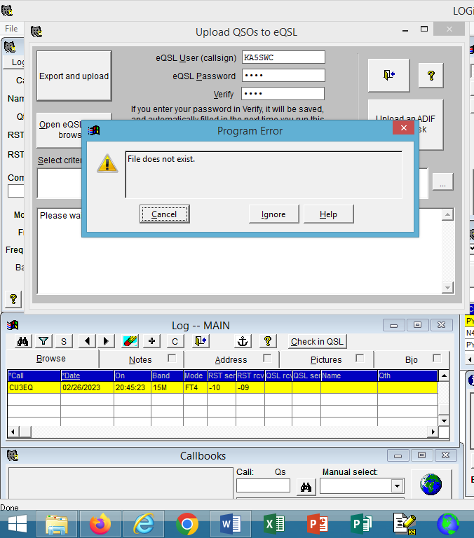 this says: File does not exist
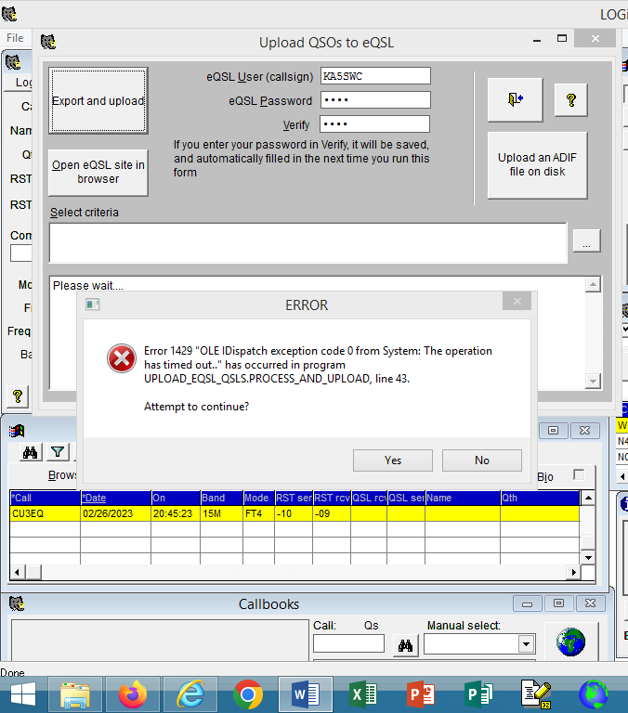 hope you can read this
On the download: I get the same four messages
